Title for GCSTMR Conference Paper, Times New Roman 16pt Bold

Belinda M Yaris¹ and Chris Sherman²

¹Position, Name of Organisation, City, Country
²Position, Name of Organisation, Authority or Company, City, Country
Corresponding author’s E-mail: b.yaris@yahoo.com

Abstract
Abstract should be in Times New Roman 11 justified in italic font. Abstract should contain 200 to 300 words.

Keywords: List 3 to 5 keywords, separated by commas.

Introduction (Times New Roman Bold 14 ALL Caps
You must use this template in preparing your manuscripts for GCSTMR conferences. You should save this file in your disk and “save as” using file name based on the first author’s surname (e.g. YARIS.doc). You must use MS word in preparing your manuscript.

Full paper must be in the range of 4 to 6 pages long including tables, figures and list of references.

The text in the body of the paper will be in Times New Roman 11-point.

Heading Level 2 (Times New Roman 12 Bold)
This template, complete with header and footer formats, will make it easy to lay out your paper for the proceedings of GCSTMR.

Your manuscript should contain an introduction, main body (data, method, results, discussion, etc) and a conclusion.

Margins and page allowance
Set out your paper on A4 size the same as this, with margins as described in Table 1.

Table 1. Margins to use in this paper

Margin | Size
Inner (gutter) | 25mm
Outer | 25mm
Top and bottom | 25mm

For Microsoft Word users the Page Setup Dialog should appear as shown in Figure 1. Centre your Figures and Tables.

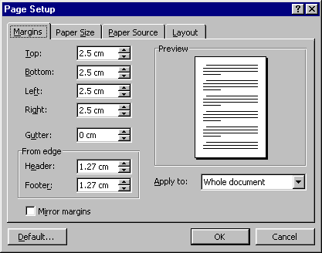
Figure 1. Page Setup Dialog Box (Margins) for formatting GCSTMR conference papers

Page numbers should be placed on the outside bottom of each page in the footer margin. Number your pages 1, 2, 3, … of 'the total number of pages'. See Footer below.

Tables and Figures
Tables should be labelled Table 1, Table 2, … at the top of each table. Figures should be labelled as Figure 1, Figure 2, … below the figures.

Units
Use S.I. system.

Footers and headers
The header in Times New Roman 9-point italics should state the paper title on the left (abbreviated if necessary), and the last name of first author of the paper. The header will be suppressed on the title page.

The footer in Times New Roman 9-point italics should follow the format shown in the footer.

Equations
Equations should be centred as below:

A = b + yt_{j} (1)

The equation should be separated by a blank line above and below, and the equation number should be right aligned on the right margin. When you reference equations in the text, use the equation number, e.g. using Equation 3, it can be seen that they are correlated.

ACKNOWLEDGMENTS
We acknowledge Mr X in Organisation Y.

In-TEXT REFERENCES
For in-text references, please see the examples below.

The paper adopted a methodology as suggested by Smith (1980), Smith and Jones (2008), Smith et al (2010), Sydney Water (2011) and BWDB (2014).

References AT THE END OF MANUSCRIPT (Follow HARVARD STYLE

Hounslow, A., 2018. Water quality data: analysis and interpretation. CRC press.

Kordrostami, S., Purdy, D. and Rahman, A., 2016. Teaching and learning of advanced statistical hydrology using a blended learning approach: a case study in Western Sydney University. In Proceedings of International Conference on Engineering Education and Research, 21-24 November 2016, Western Sydney University, Parramatta Campus, Sydney, Australia.

Micevski, T., Hackelbusch, A., Haddad, K., Kuczera, G. and Rahman, A., 2015. Regionalisation of the parameters of the log‐Pearson 3 distribution: a case study for New South Wales, Australia. Hydrological processes, 29(2), pp.250-260.

Rahman, A. and Al-Amin, M., 2015. Teaching of fluid mechanics in engineering course: a student-centered blended learning approach. In Curriculum Design and Classroom Management: Concepts, Methodologies, Tools, and Applications (pp. 1093-1101). IGI Global.

