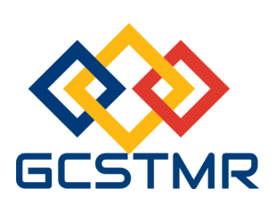
Global Circle for Scientific, Technological and Management Research (GCSTMR)
http://www.gcstmr.com.au
12 Boyer Pl, Minto, NSW 2566, Sydney, Australia
==========================================================
International Conference on Machine Learning and Data Engineering (iCMLDE)
03-07 December 2018, Sydney, Australia
(REGISTRATION FORM)
Please complete this registration form and email the completed form to secretary@gcstmr.com.au. A receipt of payment will then be emailed to you.
Paper ID
Paper Title
Registrant details | Name:  Address:  Email:  Contact Telephone No:
Registration Type (Please tick) | - Full registration - Early bird: $695 Bird on time: $750  - Student registration - Early bird: $450 Bird on time: $550  - Daily registration (for one day) - Early bird: $400 Bird on time: $450  - Accompanying family member - Early bird: $300 Bird on time: $350  - Conference dinner: $100  Early bird rate closes on 15 Nov 2018. Bird on time closes on 16 Nov 2018.
Total Amount paid
Registration date
(For daily registrant)
Transaction ID
(Payment details)

